
DecoVibe

Metal Wall Art Category

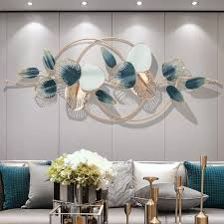
This luxury golden leaf wall art is crafted with premium quality metal and finished with a rich gold polish.
Its modern design enhances the elegance of living rooms, bedrooms, and offices.
Rust-resistant coating ensures long-lasting shine and durability.

